Software Requirement Specification

*Project: TopJobs*

# Problem Statement

TopJobs Inc. is a company that renders recruitment services in the US. With a network of more than 30 offices nationwide, the company specializes in the areas of accounting, finance, sales, marketing, information technology, and engineering. The company provides services for full-time, part-time, and contractual employment. Many competitors of the company already have their job portals and are providing recruitment services online. TopJobs is losing its clients to competitors because employers prefer viewing and selecting resumes and communicating with prospective candidates online, before meeting in person. The management of TopJobs has realized that in order to grow and sustain in the job recruitment market, it will need to update its current system by creating an online job recruitment application that can be used by both employers and jobseekers.

# Microservices

## Authentication Service

Registers and authenticates users and provides JWT token.

* /register
* /login

Model : User

* username : String (Pkey)
* password : String
* role : String

## Admin Service

Provides various services for Admin users

* /registerAdmin
* /viewAdmin/{adminID}
* /deleteAdmin/{adminID}
* /updateAdmin/{adminID}

Model: Admin

* username : String (Pkey)
* firstName : String
* lastName : String
* email : String
* phoneNumber : Number
* address : String

## Employer Service

Provides various services for Employer users

* /registerEmployer
* /viewAllEmployers
* /viewEmployer/{employerID}
* /updateAccountStatus/{employerID}
* /updateEmployer/{employerID}
* /deleteEmployer/{employerID}

## Model : Employer

* username : String (Pkey)
* companyName : String
* email : String
* phoneNumber : Number
* address : String
* Boolean AccountStatus

## Job Service

Provides various services for Jobs

* /addJob
* /viewAllJobs
* /viewAllJobsByEmployerId/{employerID}
* /viewAllJobsByJobSeekerId/{jobSeekerID}
* /viewJob/{jobID}
* /updateJob/{jobID}
* /updateJobStatus/{jobID}
* /updateJobApplicantList/{jobID}
* /updateJobSelectedApplicantList/{jobID}
* /deleteJob/{jobID}

## Model: Job

* jobID : String (Pkey)
* employerID : String
* title : String
* location : String
* description : String
* postedDate : LocalDateTime
* status : String
* applicantList : List<String>
* selectedApplicants: List<String>

## JobSeeker Service

Provides various services for Job Seekers

* /registerJobSeeker
* /viewAllJobSeekers
* /viewJobSeeker/{jobSeekerID}
* /updateJobSeeker/{jobSeekerID}
* /updateJobSeekerResume/{jobSeekerID}
* /deleteJobSeeker/{jobSeekerID}

## Model : Job Seeker

* username : String (Pkey)
* firstName : String
* lastName : String
* email : String
* phoneNumber : Number
* address : String
* resume : String

# UI – Design

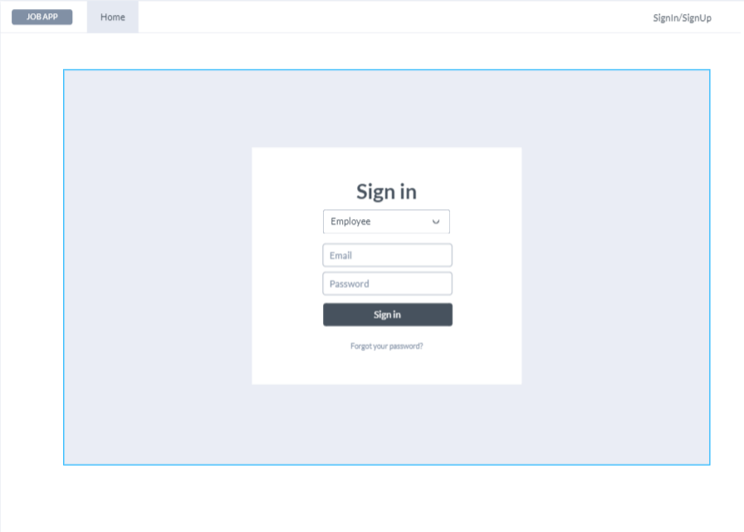

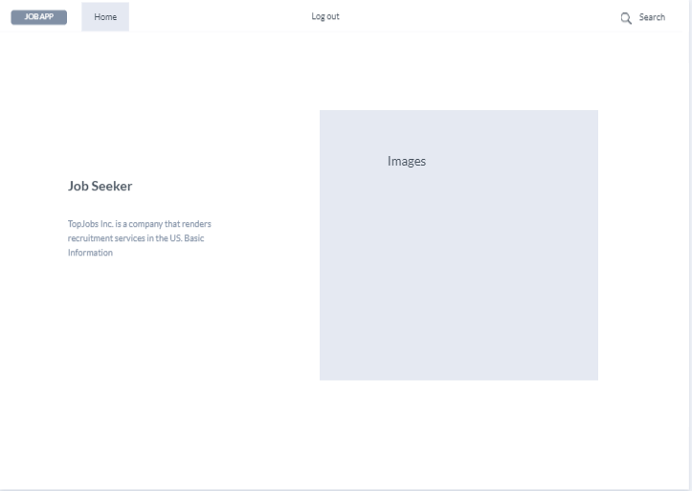

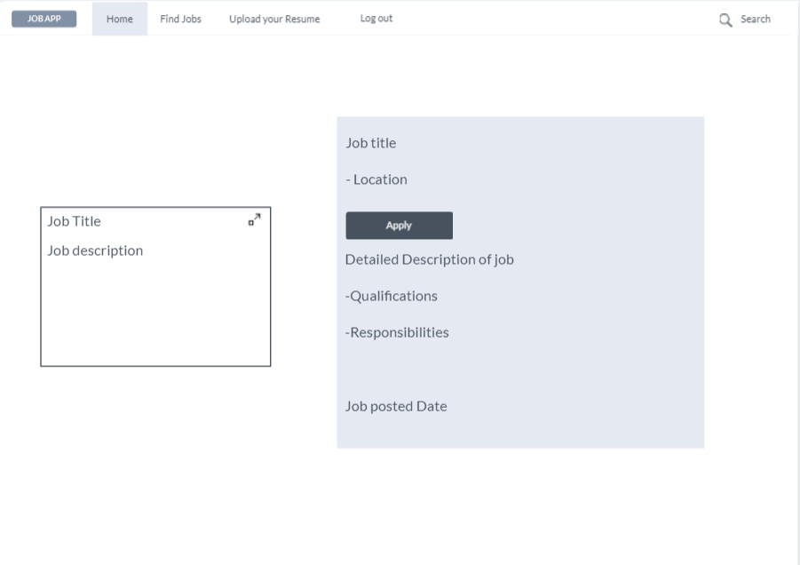

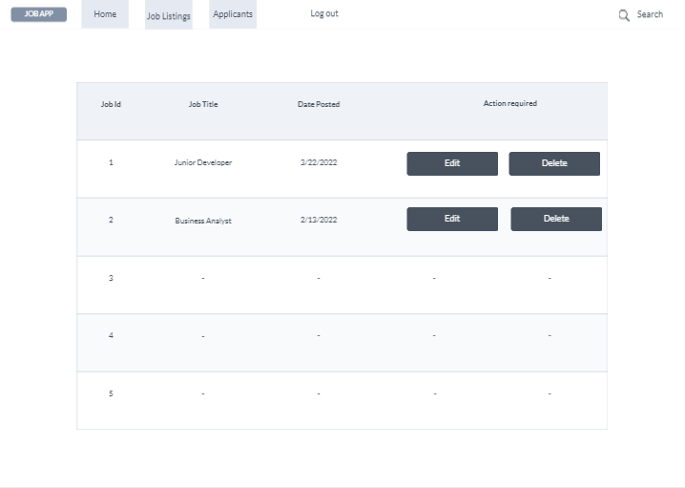

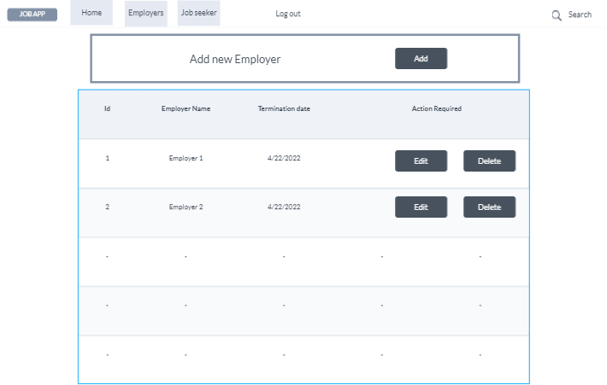

Database Diagram

